

**Diocese of Imus Catholic Educational System, Inc.**

**OUR LADY OF THE PILLAR CATHOLIC SCHOOL, INC.**

**F. Tirona St., Pob. II-A, City of Imus, Cavite 4103**

FB: @PillarSchoolImus|(046) 471-3206 | olpcs_imus@yahoo.com

**LEARNING ACTIVITY SHEET**

Name:__________________________________________________________ Score: ________________________________

Grade and Section: ______________________________________________ Date: ________________________________

Activity Title: Getting information from news Activity Number: 1

Type of Activity: _______________________________________________________________________________________

Learning Targets: **Get information that can be used in everyday life from news reports, speeches, informative talks, panel discussions, etc. EN10LC-Ia-11.1**

Values/Graduate Attribute: Reflective and Critical Thinkers

References:____Newspaper______________________________________________ Page Number: N/A

**Directions:** Cut out one news article in a newspaper and highlight the important information which answers the essential information below.

***1.who-***

***2.what-***

***3.where-***

***4.when-***

***5.why-***

***6.how-***

_______________________________ _________________________

Teacher’s Signature Date



**Diocese of Imus Catholic Educational System, Inc.**

**OUR LADY OF THE PILLAR CATHOLIC SCHOOL, INC.**

**F. Tirona St., Pob. II-A, City of Imus, Cavite 4103**

FB: @PillarSchoolImus|(046) 471-3206 | olpcs_imus@yahoo.com

**LEARNING ACTIVITY SHEET**

Name:__________________________________________________________ Score: ________________________________

Grade and Section: ______________________________________________ Date: ________________________________

Activity Title: Linear and Non-linear texts Activity Number: 1

Type of Activity: _Seat work

Learning Targets: **Transcode information from linear to non-linear texts and vice-versa**

Values/Graduate Attribute: Reflective and Critical Thinkers

References: Teacher-made material Page Number: N/A

**Concept Notes**

Activity No. 1 (Think, pair and share)

Let the student look for their partner. Each pair will create and choose a non-linear text to present

the information below. After the allotted time given, call at least 5 pairs to present their work in

front.

A. The different chores we perform at home.

B. The 5 things we will buy if we have ten thousand pesos. (Indicate prices)

Activity No. 1 (Think, pair and share)

Let the student look for their partner. Each pair will create and choose a non-linear text to present

the information below. After the allotted time given, call at least 5 pairs to present their work in

front.

A. The different chores we perform at home.

B. The 5 things we will buy if we have ten thousand pesos. (Indicate prices)

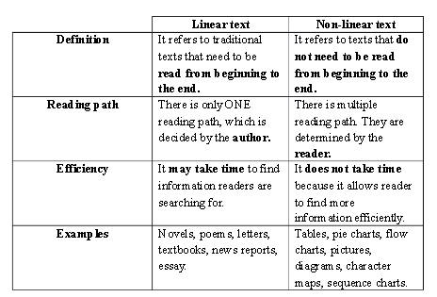

To transcode means to transform something from one for to another. In order to transcode a linear to non-linear texts or the other way around, one must first be able to fully understand what the source text is about. This way, deciding in the proper text type to be used in the transcoding process will be easier.

Step 1. Read and understand the source text to get its main or central idea.

Step 2. Extract important details to be included in the visual presentation.

Step 3. To be organized, classify information into categories.

DIRECTIONS: Read the following linear text and transcode it to non-linear text.

**TO COOK SCRAMBLED EGGS**

Procedure: First, get ready of the following ingredients:

4 ounces of white fish meat, finely minced

2 ½ tablespoon flour

½ teaspoon salt

6 eggs beaten

3 tablespoon sugar

Oil

Next, mix together fish, flour and salt. Then, add beaten eggs and mix well. When thoroughly blended, add sugar. Heat oil in a pan, and then pour in egg mixture. Cover and simmer for fifteen minutes. Turn and cook the other side. Finally, slice and make four servings Slice

_______________________________ _________________________

Teacher’s Signature Date

D. Application

Direction: Group the class into 2 groups. Choose a leader per group and get a card from your teacher. Be ready to present your task in class. The task will be graded using the rubric provided.

Group 1. Transcode a linear text to non-linear text. (Make a sequence chart based from this paragraph.)

What are you going to do if your clothes caught fire during an emergency situation? Here are the things you should do: First, stop where you are – moving or running feeds air to the flames and worsen the fire. Next, drop to the floor – if you stand up, the fire can burn your face. Fold your arms high on your chest to protect your face. Then, roll slowly on the floor or ground, in a rug or blanket if you can. Afterwards, cool off as soon as possible with water or first- and second-degree burns. Finally, to escape fire, get down low and go.

Group 2. Transcode the bar graph into short paragraph (The bar graph shows the global penetration og Social Platforms)

